# Assignment-4

1. **Microsoft Azure**

BLOB and web data is transmitted, saved, and processed by Azure hubs to perform analytics, allowing developers to create data-driven applications. Azure statistics may be visualized using sensors and Power BI applications.

1)

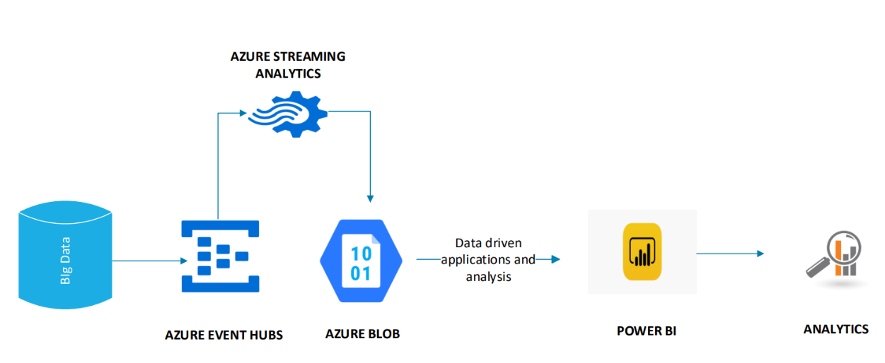

2)

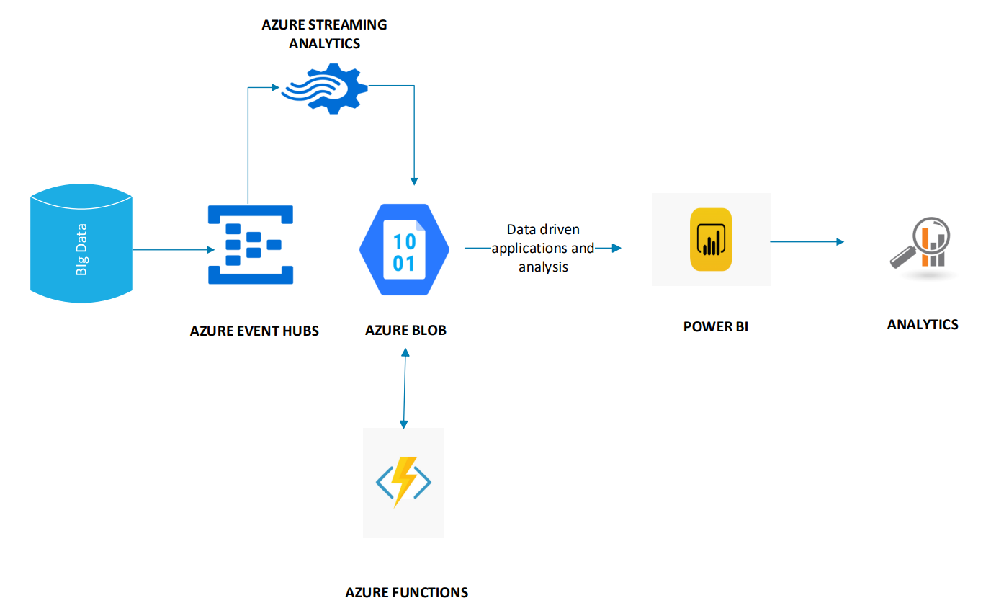

3)

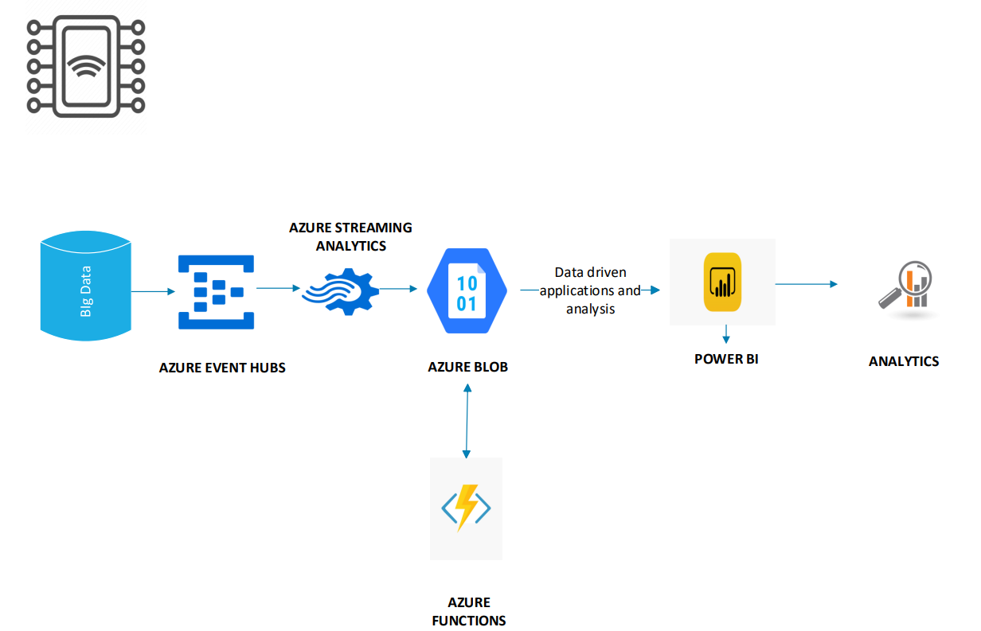

4)

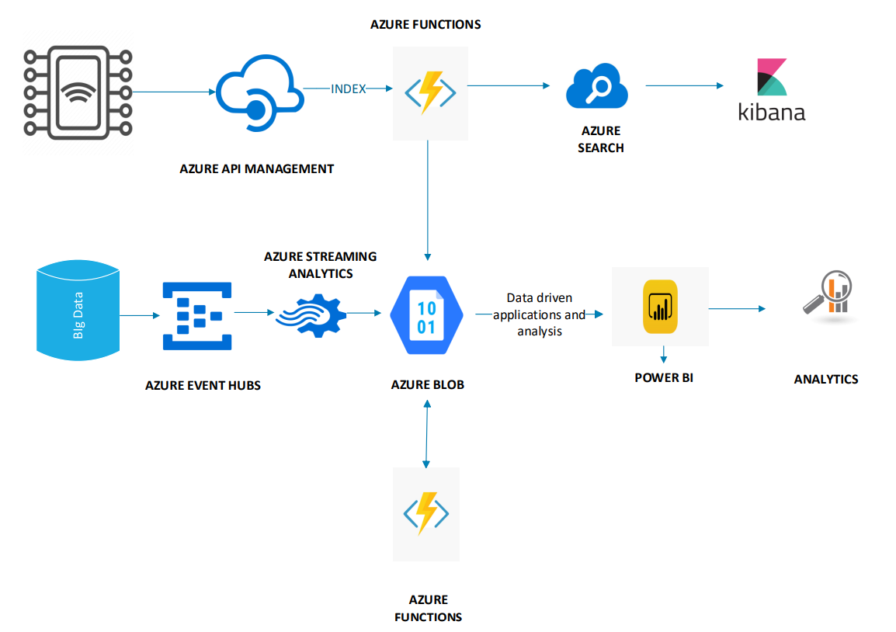

1. **Google Cloud**

For architects, developers, administrators, and other cloud users, Google's cloud architecture provides best practices. Data is accessible through any online application that allows data flow, and it is saved in Google's own data storage.

This can be queried through a query gateway, and data analysis can be done using visualization techniques.

1)

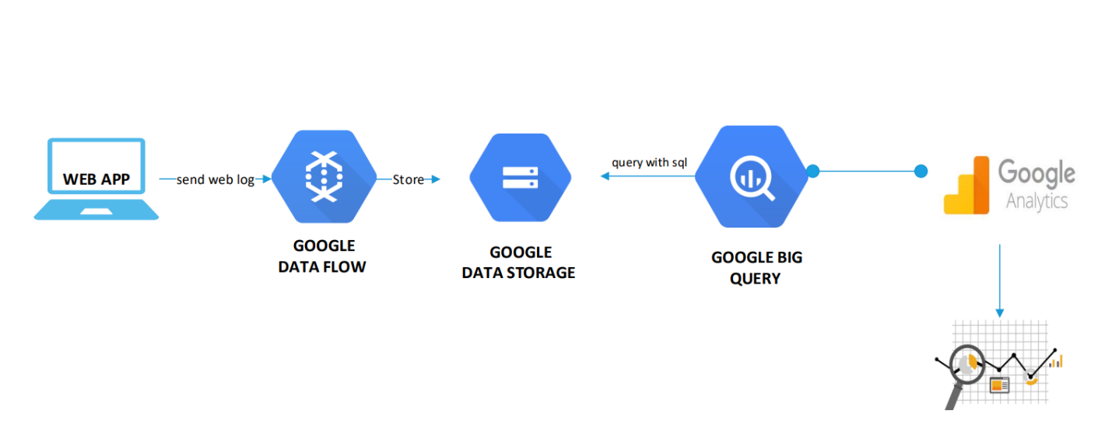

2)

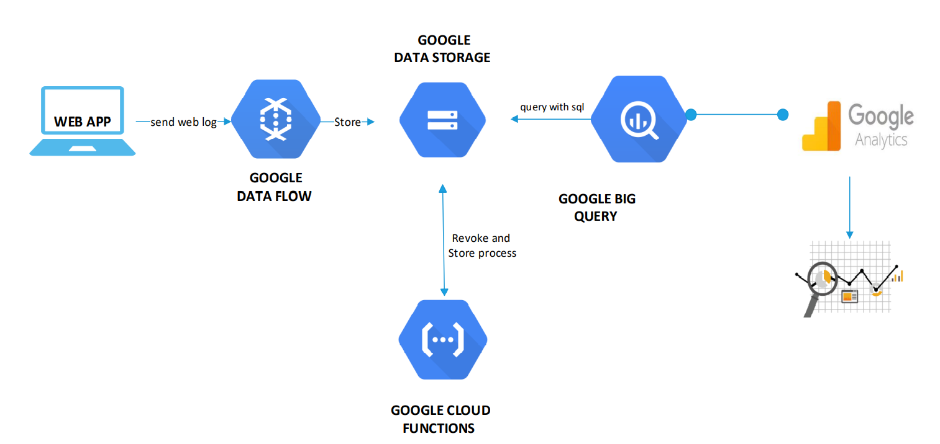

3)

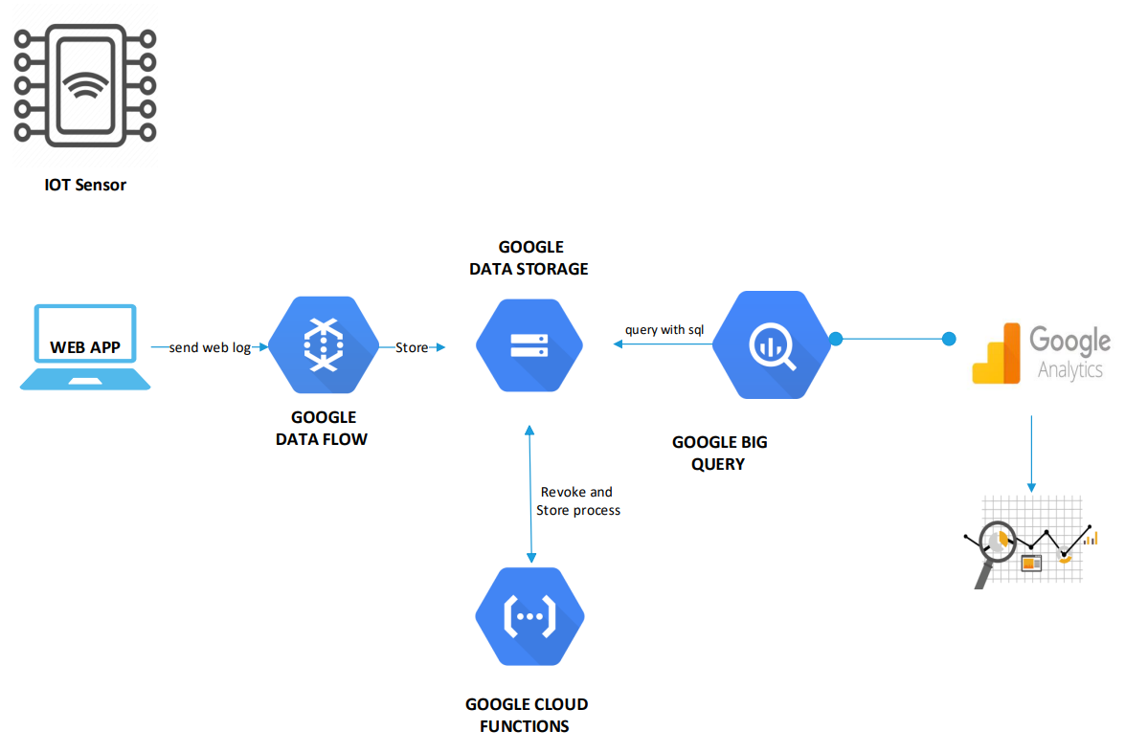

4)

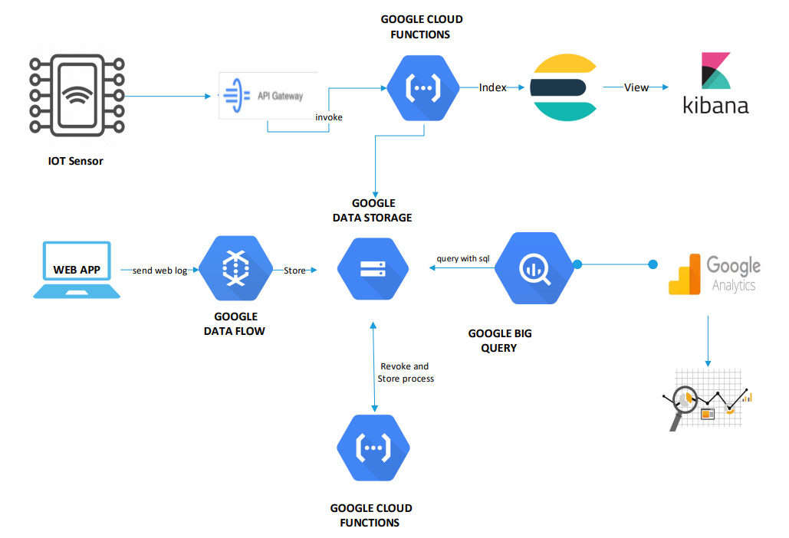

1. **Hadoop**

Hadoop Architecture serves mostly as a filesystem.

It's a hybrid of MapReduce and Hadoop Distributed File System (HDFS).

MapReduce is used to program webserver logs, which are then saved in HDFS.

This information can be accessed using MySQL - SQL (question portal).

A complex Hadoop system focuses on IoT sensors, which generate generic data that is delivered over HTTPS to Apache Knox, which is then triggered for data processing and visualized using visualization technology.

1)

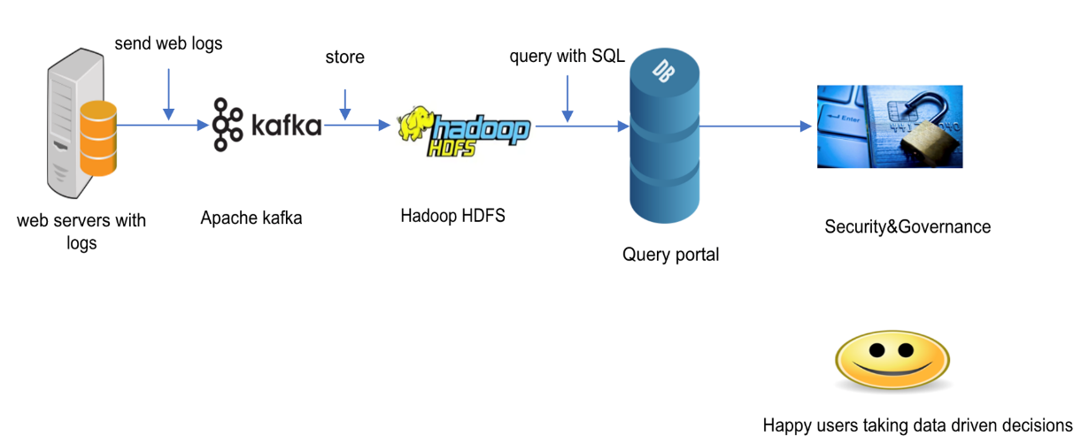

2)

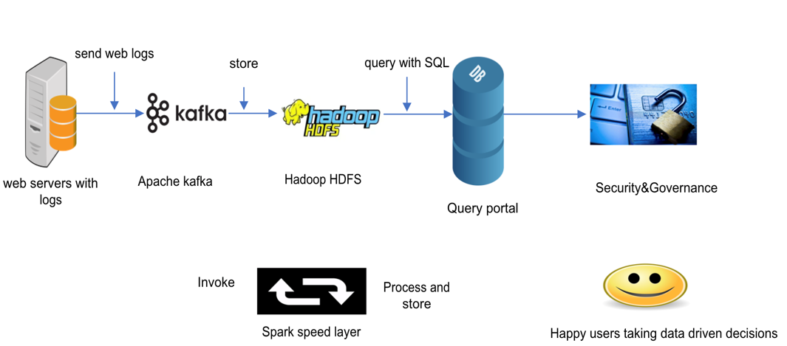

3)

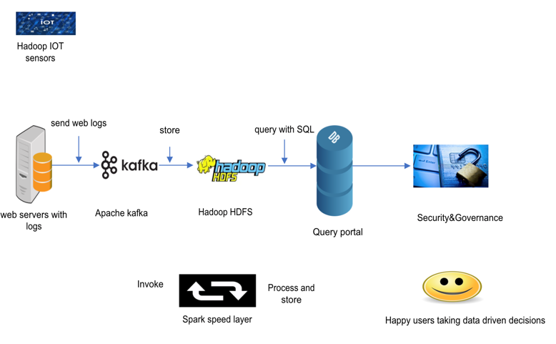

4)

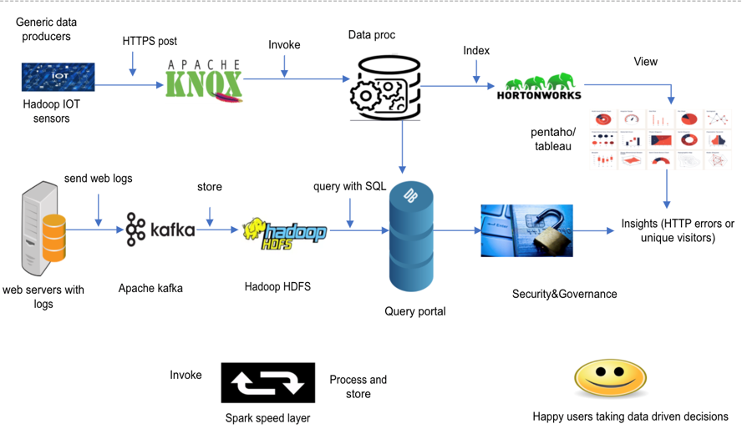

1. **Amazon Web Services (AWS)**

Because applications and websites generate massive volumes of data every day, Amazon Web Services (AWS) provides advanced cloud services to manage data processing techniques in the cloud. AWS architecture provides the greatest advice and suggestions for developing and maintaining systems.

Additional Amazon agents such as Kinesis or S3 can be used to manage the enormous volume of data (including logs). The query portal can be used to get this information. These can be triggered by IoT sensors, then processed and stored in Amazon's cloud.

1)

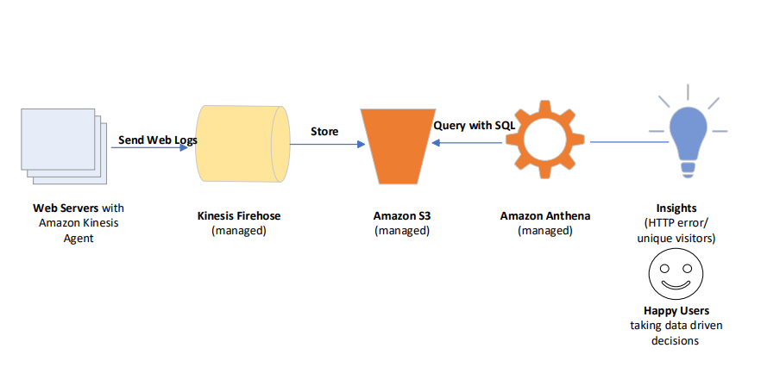

2)

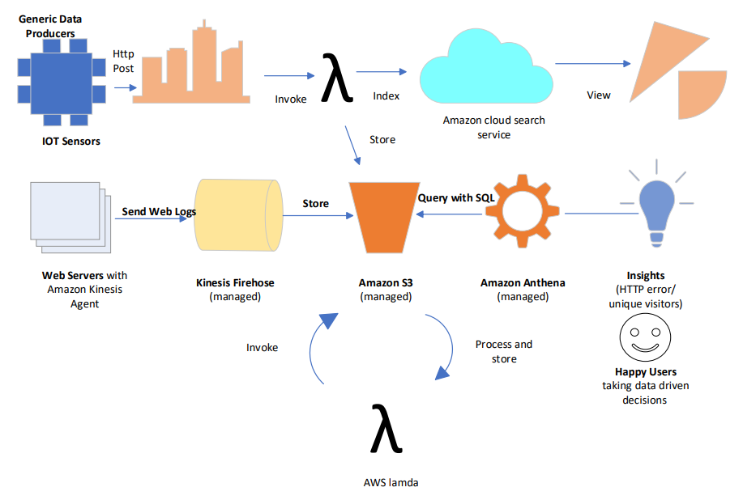

3)

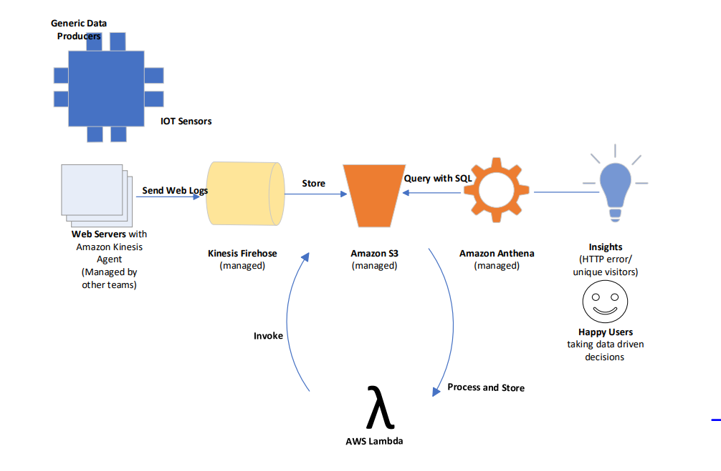

4)

